
Email:milleniumstar.enterprise@ymail.comTelefax:(049)5081582

QUOTATION
To:PriconMSE-050621
Attn: Ms. Rebecca Valenzuela May 6,2021

Ma’am,
We are pleased to quote you as follows.We highly appreciated your interest in our company.
And we are looking forward in seeing your purchase order.Thank you very much for your inquiry.
ITEM QTY. DESCRIPTION Unit Price Total Amount
1 4sets Stereo microscope with 48led lamp Usd455.00/pc Usd1820.00
7X-45X Zoom Stereo Microscope,pcb inspection machine
This zoom microscope adopts streamline integrated mechanical design, Easy operation, long working distance,clear resolved image, enclosure integrated. The microscope is used extensively world medical research and health care, biology and botany research, and agricuture, as well as in electroniccomponent manufacturing. Especially suited for LED, PCB inspecition, pressing plating and electronic component inspection
Specification:
1.Binocular Head Angle of viewing:45º
2.Zoom ratio:1:6.4
3.Eyepiece:WF10X/20mm
4.Objective:0.7x-4.5x magnification is 7x-45x
5. Interpupillary distance adjustment range :55-75mm
6.Working distance:100mm
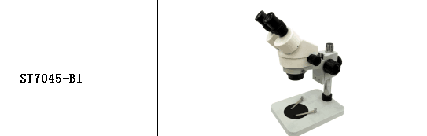

Delivery:2weeks
Terms:End of next month after the month end closing

If you have any queries please don’t hesitate to contact us
Sincerely ,
Johnna Villaceran

